**📄 API Documentation: Food Rescue Feature**

This documentation provides details on the **three APIs** for the **Food Rescue feature**, including authentication, request/response formats, and security considerations.

* **Authentication**

All API requests must include an api_key for authentication.

* **Authentication Table Structure:**

CREATE TABLE api_keys (

id INT PRIMARY KEY AUTO_INCREMENT,

api_key VARCHAR(64) UNIQUE NOT NULL,

created_at TIMESTAMP DEFAULT CURRENT_TIMESTAMP

);

* **Example Query to Validate API Key:**

php

function authenticate_request($db, $api_key) {

$db->where("api_key", $api_key);

return $db->getValue("api_keys", "id") ? true : false;

}

**📌 API 1: Mark Order as Canceled & Add to Food Rescue**

**📍 Endpoint:** POST /{base_url}/cancel-order

**📌 Description:** Marks an order as **canceled** and adds it to the **Food Rescue system**, making it available for resale.

* **Request Parameters (JSON)**

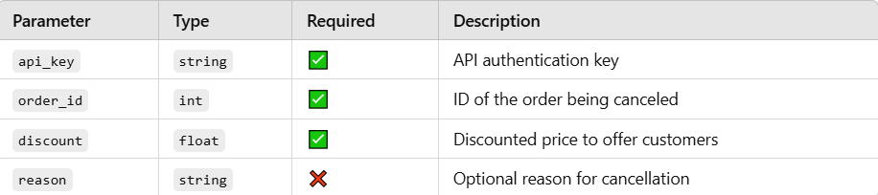

* **Example Request (JSON)**

json

{

“api_key”: “your_api_key_here”,

“order_id”: 12345,

“discount”: 20.00,

“reason”: “Customer canceled”

}

* **Response Format**

json

{

“success”: true,

“message”: “Order marked as canceled.”

}

**📌 API 2: Retrieve Canceled Orders Near Customer**

**📍 Endpoint:** POST /{base_url}/get-canceled-orders

**📌 Description:** Fetches **canceled orders** within a **3 km radius** of a customer’s location, respecting their **food preferences**.

* **Request Parameters**

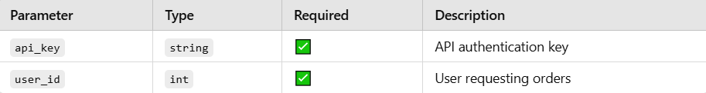

* **Example Request (JSON)**

json

{

“api_key”: “your_api_key_here”,

“user_id”: 2

}

* **Response Format:** {

"success": true,

"orders": [ {

"id": 456,

"discounted_price": 150.00,

"latitude": 17.385044,

"longitude": 78.486671,

"restaurant_name": "Tandoori House",

"items": [ {

"item_name": "Paneer Butter Masala",

"category": "vegetarian",

"price": 200

},

{

"item_name": "Tandoori Roti",

"category": "vegetarian",

"price": 30

}] }]}

**📌 API 3: Claim a Canceled Order**

**📍 Endpoint:** POST /{base_url}/claim-order

**📌 Description:** Allows a **customer** to claim a **canceled order** and proceed to **payment**.

* **Request Parameters (JSON)**

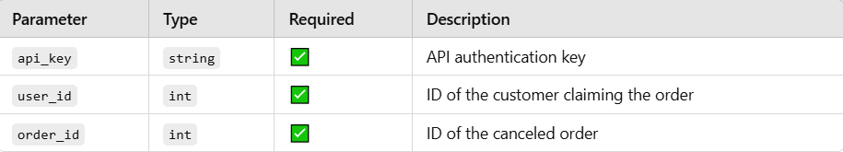

* **Example Request (JSON)**

json

{

"api_key": "your_api_key_here",

"user_id": 123,

"order_id": 456,

}

* **Response Format**

json

{

"success": true,

"message": "Order successfully claimed",

}

**🚀 Conclusion**

This API system is designed for **high performance, security, and scalability** with: ✅ **Optimized queries** for 1M+ orders.  
✅ **Caching (Redis)** for reducing database load.  
✅ **Indexing** for **faster** query execution.  
✅ **Security enhancements** like rate-limiting & API authentication.